Assignment 1 – Introduction To Software Development
CSC 300 Fall 2026
Notes: All homework must be submitted via e-mail.
E-mail address is:
csc300csudh@gmail.com
The homework file should be submitted with your name using the following format:
RosenthalH_AZ.docx, where Z is the assignment number. Note: use your name, not mine
Total Points - 107

Short answer questions.

- Describe the difference in scheduling between agile and traditional software development methodologies. (8)
The main difference between agile and traditional is the phase in which most of the planning takes place. For example, agile development has a general idea of a goal and small steps will be taken to move forward to reach that goal. As complication arise for each of the steps, solutions will be created and implemented into the overall blueprint for that goal. As for traditional development, the planning mostly take place at the beginning with a clear idea of the goal. This forces the project head/planner to predict many variables ahead of time and account for it into the planning, such as budget, delays in sourcing, contracting, etc.

- List 4 key responsibilities of a software engineer. (8)
1) Design and develop software systems with scalability, security, and
performance
2) Create and maintain software architecture diagrams and documentation.
3) Choose appropriate development tools and technologies for a project.
4) Analyze system requirements and translate them into technical
specifications.

- List and describe 10 key considerations in software engineering (30)

Abstraction – hide complex implementaion behind simpler interfaces or API’s (Application Programing Interface)
Compatibility – the software is able to work with other products that were meant for interoperability. Working with other versions of itself, older hardware, etc
Cost and Time - Contractual requirements ,internal dependencies, Market timing (to early or to late to the market). The expected cost of the projects material, R&D, labor, etc. The expected timeline for material delivery, expected/possible delays, and rollout time between steps for projects.
Coupling & Cohesion - Coupling: Degree of dependency between modules. Low coupling is ideal. changes in one module minimally impact others
Cohesion: How closely related a module’s responsibilities are. High cohesion is desirable. each module has a clear, focused purpose.
Extensibility – New capabilities can be added to the software without major changes to the underlying architecture. Layman’s term, the ability to be updated easily
Fault-tolerance and Robustness – The software’s resistant to and able to recover from component failure. The software’s ablility to operate under stress or tolerate unpredictable or invalid input. (low memory, user error wont blow it up, sudden high traffic wont crash, etc)
Maintainability and Testability – A measure of how easily bug fixes or functional modifications can be accomplished. High maintainability can be the product of modularity and extensibility. EG. easily verified with automated tests, reduces bugs and regression issue (having to go back to previous version because new update broke something.) Support TDD (Test-Driven Development) and BDD (Behavior-Driven Development)
Modularity – Breaking the system into smaller, self-contained units or modules. Easier to maintain and test individual modules. Supports parallel development by multiple teams (EG. multiple programmers working on a github and pushing to update) The better the modularity the higher the maintainability.
Performance – The software performs its tasks within a time-frame that is acceptable for the user.
Portability – The software should be usable across a number of different conditions and environments.
Reliability – The software is able to perform a required function under stated conditions for a specified period of time. MTBF (Mean Time Between Failures): The average amount of time a system operates without a
failure. Higher MTBF indicates higher reliability. MTTR (Mean Time to Repair): The average time it takes to recover from a failure.
Resource Utilization - Remaining within required resource specifications including processor utilization, memory and storage. (note google chrome with ram consumption)
Scalability and Reusability – Ability to grow and adapt the system as requirements evolve. Future-proofs the design. The ability to use some or all of the aspects of the preexisting software in other projects with little to no modification. Supports adding new features without rewriting existing code. The software adapts well to increasing data or added features or number of users.
Security – The software is able to withstand and resist hostile acts and influences.
Usability – The software user interface must be usable for its target user/audience. Include the end-users in your design

- List and describe 5 key practices in Software Development (15 points)
Good design and definition of interfaces - Interfaces allow us to encapsulate and then hide implementation details. Interfaces is usable and user most of the time won’t notice it.
Automated testing - Tools capture test scenarios for playback so that they can be run multiple times. Preemptive checks for errors are better than fixing errors later on.
Code reviews - Usually done by peers as well as management to ensure that software is correct and meeting requirements. It helps advoid fudging by programmers
Low complexity – The more simple the code, generally the less number of test needed to maintain the program.
Good documentation – Helps other people work and take over coding project more easily.

- Describe refactoring. (4)

Refactoring is improving the software without adding new functionality. mprovements can include modernizing the code, performance improvement, bug fixes, etc. Usually incorporated in interim releases (Example to self Cyberpunk 2077 continual optimization.)

- List 5 good coding practices for Java programmers. (10)
Defining and Adhering to Naming Conventions
Ordering class members by scopes
Class Member Instance Variables Should Be Private
Avoid empty catch blocks
Using StringBuilder or StringBuffer instead of String concatenation.

- Define Static Program Analysis and give 2 examples (6)
Definition: Static Program Analysis consists of the programs or algorithms designed to extract facts from another program’s source code without executing it.

2 very simple ones include checking for any unused variables and another one is checking for syntax errors. Better to catch these early on than later while testing software

- Describe the Test Methodology For Function Testing (Look at the pdf version of the table and find the correct box) (10)
Testing Functionality based on System requirements/black box testing of software application.
Interpretted: Test each function independently to see if the output given is the desired output.
//nts ex Check an add function such as add(x,y) and make sure it adds only.

- What is cyclomatic complexity and how is it calculated? (8)
In normal terms, the cyclomatic complexity measure tells how complex your code is.
The most common formula is M = E − N + 2P
E = the number of edges of the graph.
N = the number of nodes of the graph.
P = represents number of nodes that have exit points in the control flow graph. (or often considered as the number of connected components)

Problems:
- Cyclomatic Complexity (8 points)
Calculate the cyclomatic complexity for the following figure, assuming a single exit node. Show your formula and calculation to ensure partial credit.
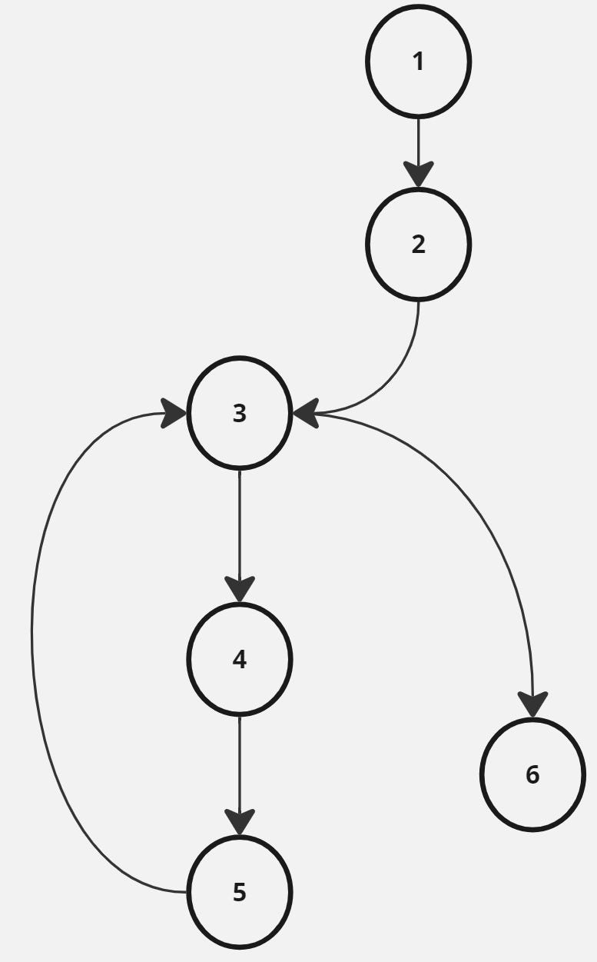

Answer:

Cyclomatic Complexity = 2
E = 6 edges N = 6 nodes P = 1 exit point
M = 6 – 6 + 2(1)
M = 2

